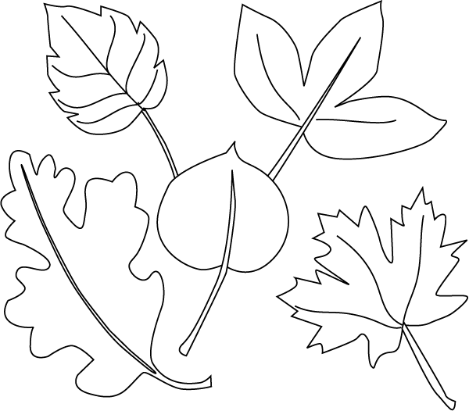
Box Top

Box Top
Box Top
Box Top
Box Top
Box Top
Box Top
Box Top
Box Top

Box Top

Please tape or glue the box tops to the leaves! Turn in to the library collection box or to your child’s homeroom teacher.
Student Name______________________________________________________________________________________
Teacher Name______________________________________________________________________________________

