TIGER TIMES
[December 2015]

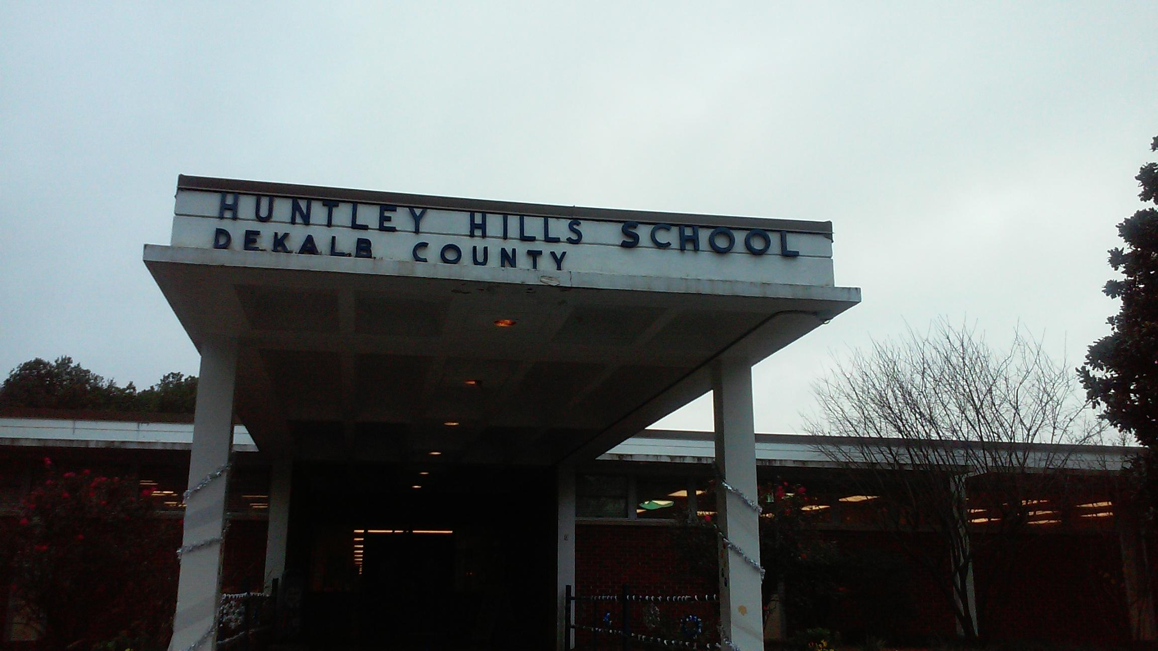
Photo of school by Jason

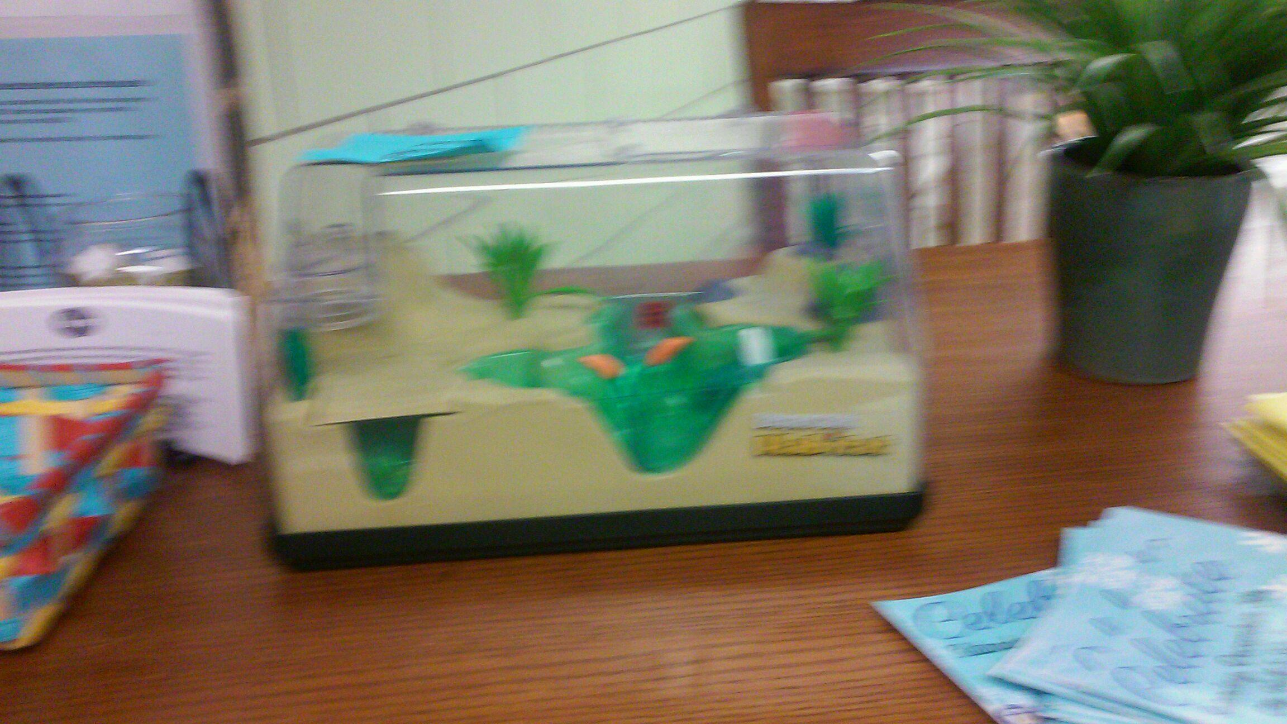
Photo by Kemora
The Missing Snake
By Kemora
Edited by Apollo
The snake is missing! Where did it go? Why did it go? Ms. Minter thinks the snake went home with a parent on “movie night.” The snake was last seen at the late attendance desk with Ms. Cabrara. Ms. Cabrara says the snake was a boy and that it was a baby. She said that she found the snake in her class. She said that the she thinks the snake is in the wild now. Dr. Ford thinks a parent took it. She said it was a parent from someone in Ms. Salzillo’s class. Mr. Creamer our custodian, does not know where the snake went and he does not like snakes. He was very concerned. Ms. Jones our Assistant Principal, does not like snakes at all. She said “the snake went home with a Huntley Hills student.” Ms. Minter said that a family took the snake to the Chattahoochee Nature Preserve and spoke with a specialist and they were told that it was illegal to keep the snake and that it had to be released into the woods. So that’s what they did!

The Nutcracker is Here!
By Terrance
Edited by Brandt
The Nutcracker is a play it is going to be performed at Huntley Hills. Everybody wants to be the Nutcracker. We’re going to do it for Christmas. We’re learning the songs with Ms. Thompson. She is in charge of the play. She says there will be singing and dancing and snowflakes for decorations. On December 17th students are coming to perform, some students are coming to watch. The Nutcracker Suite is going to be performed at the cafeteria. The time is at 6:00pm.
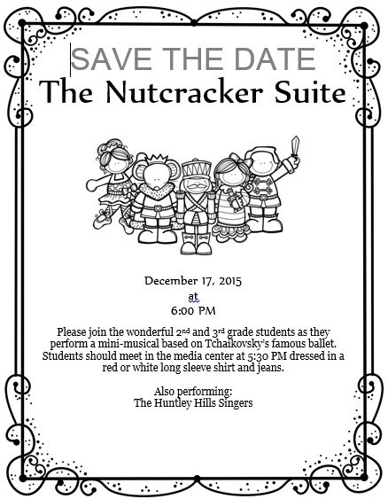

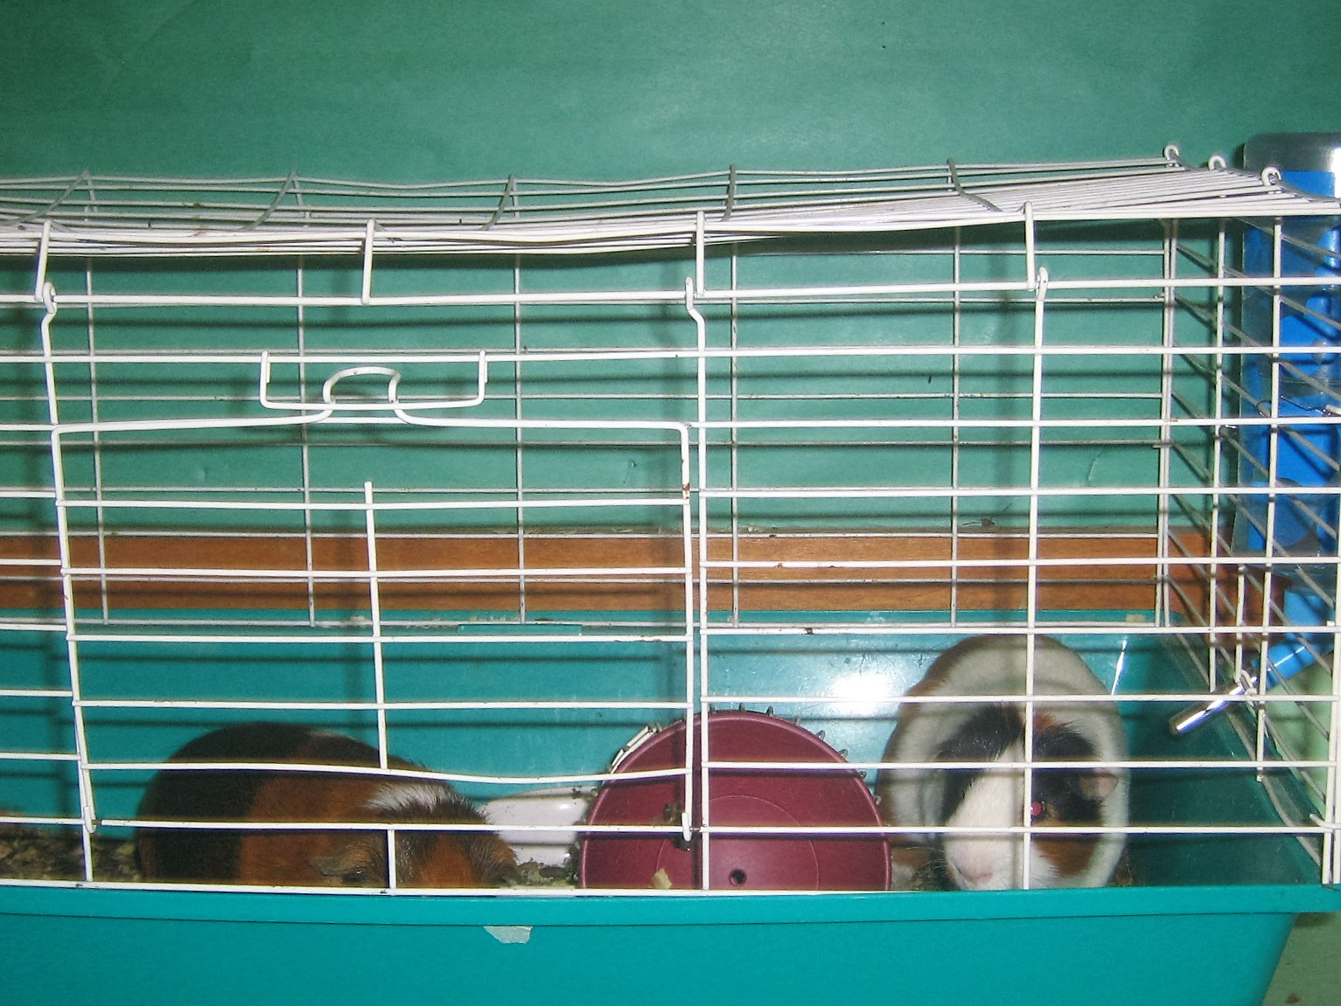
Photo of Guinea Pigs Brownie and Patrick by Talen

Pigs at Huntley Hills!
By Zack
Edited by Steven
The STEM Class at Huntley Hills School has two guinea pigs. Their names are Brownie and Patrick. The owner is Mrs. Nsele and her kids. Mrs. Nsele’s kids named the pigs. The name Patrick came from the show Spongebob Square Pants and the name Brownie is because the guinea pig is very brown. At the STEM class people are able to touch the guinea pigs and feed them. The guinea pigs eat pumpkin, lettuce, and carrots and apples.

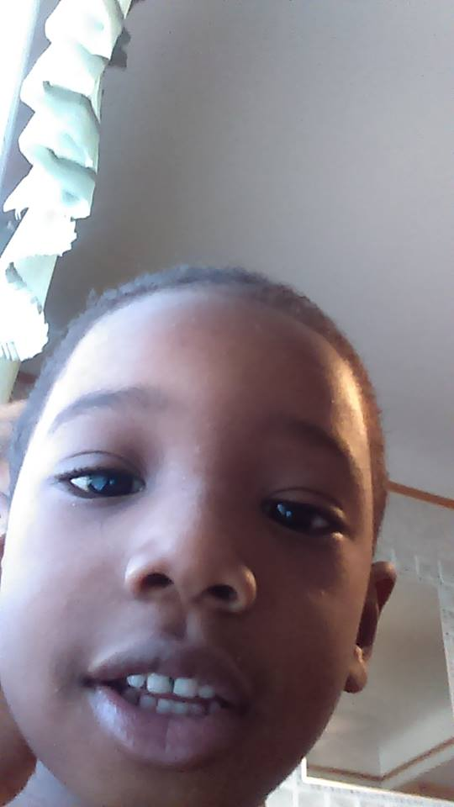
Photo of Jonathan provided by Kierston’s Mom
The Non Crying baby
By Kierston
Edited by Ronnie
When my nephew, Johnathan, was born that was the happiest day of my life. When he came home from the hospital something strange was happening at my house. We, (my mom, dad and me and my sister) put him down on the couch so we can have dinner. After dinner my dad sat down on the couch with Johnathan and it made my nephew go up in the air a little and he fell on the floor, but he did not cry! He laughed and we were all confused. We thought he would cry but he did not. Sometimes babies can be clumsy.

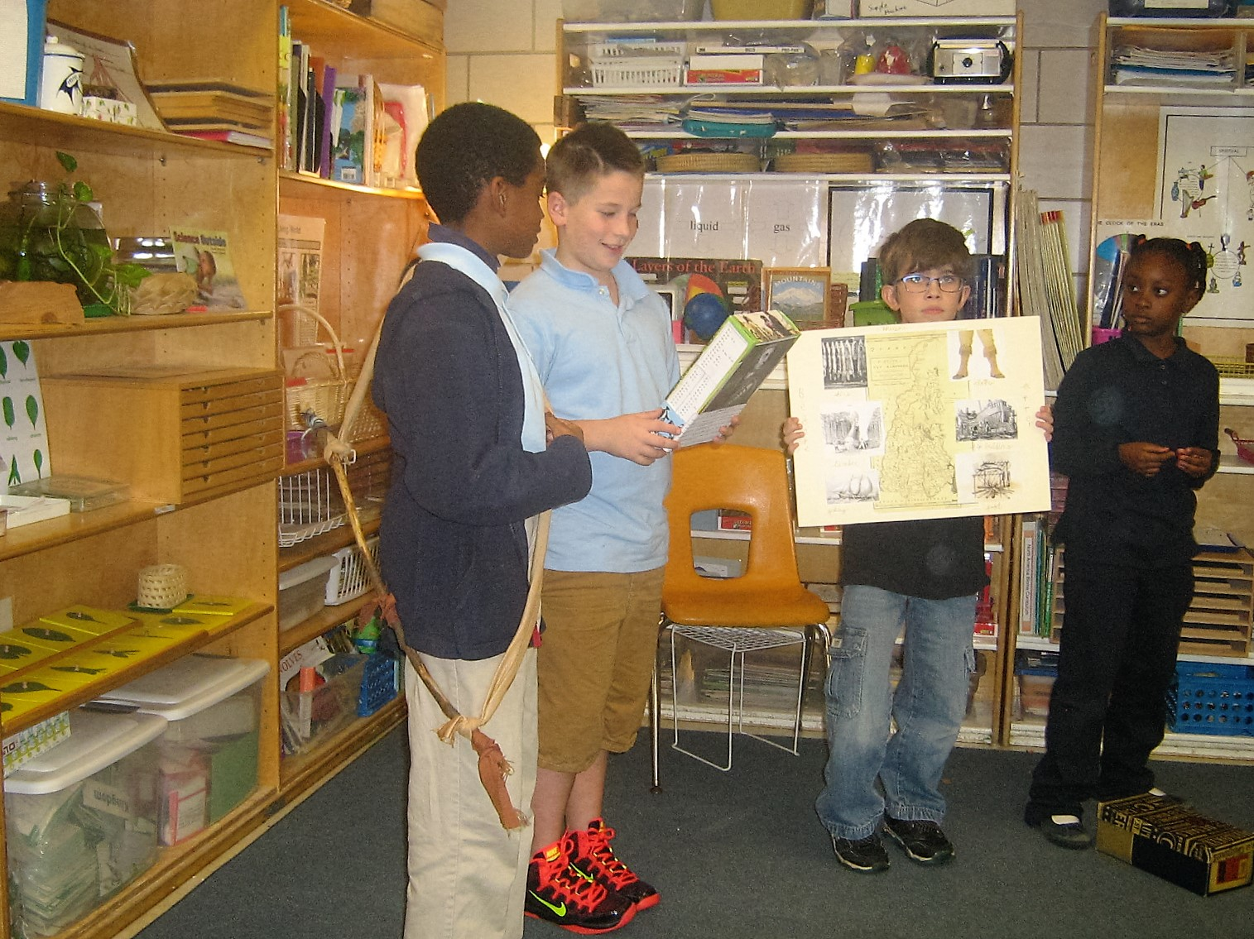
Photo of Koby, Talen, Hudson and Simone by Mohammed
Colonial Times Come to Huntley Hills
By Simone
Edited by Jaelyn
We are doing a projects on November the 17th it’s about the Creek Indians. Second grade has to build houses and moccasins. We are having a colonial lunch. We have apple pie, cherry pie, pumpkin pie, cornbread, mack and cheese, and chili. People are sharing their projects. Jason did a project about ships. Dylan made a poster about South Carolina, and Apollo also made a poster. Some students made projects on Creek Indians and others did their projects on colonies. We ate lunch while the students were doing their projects. Then we are going to the playground and after we will have the deserts.
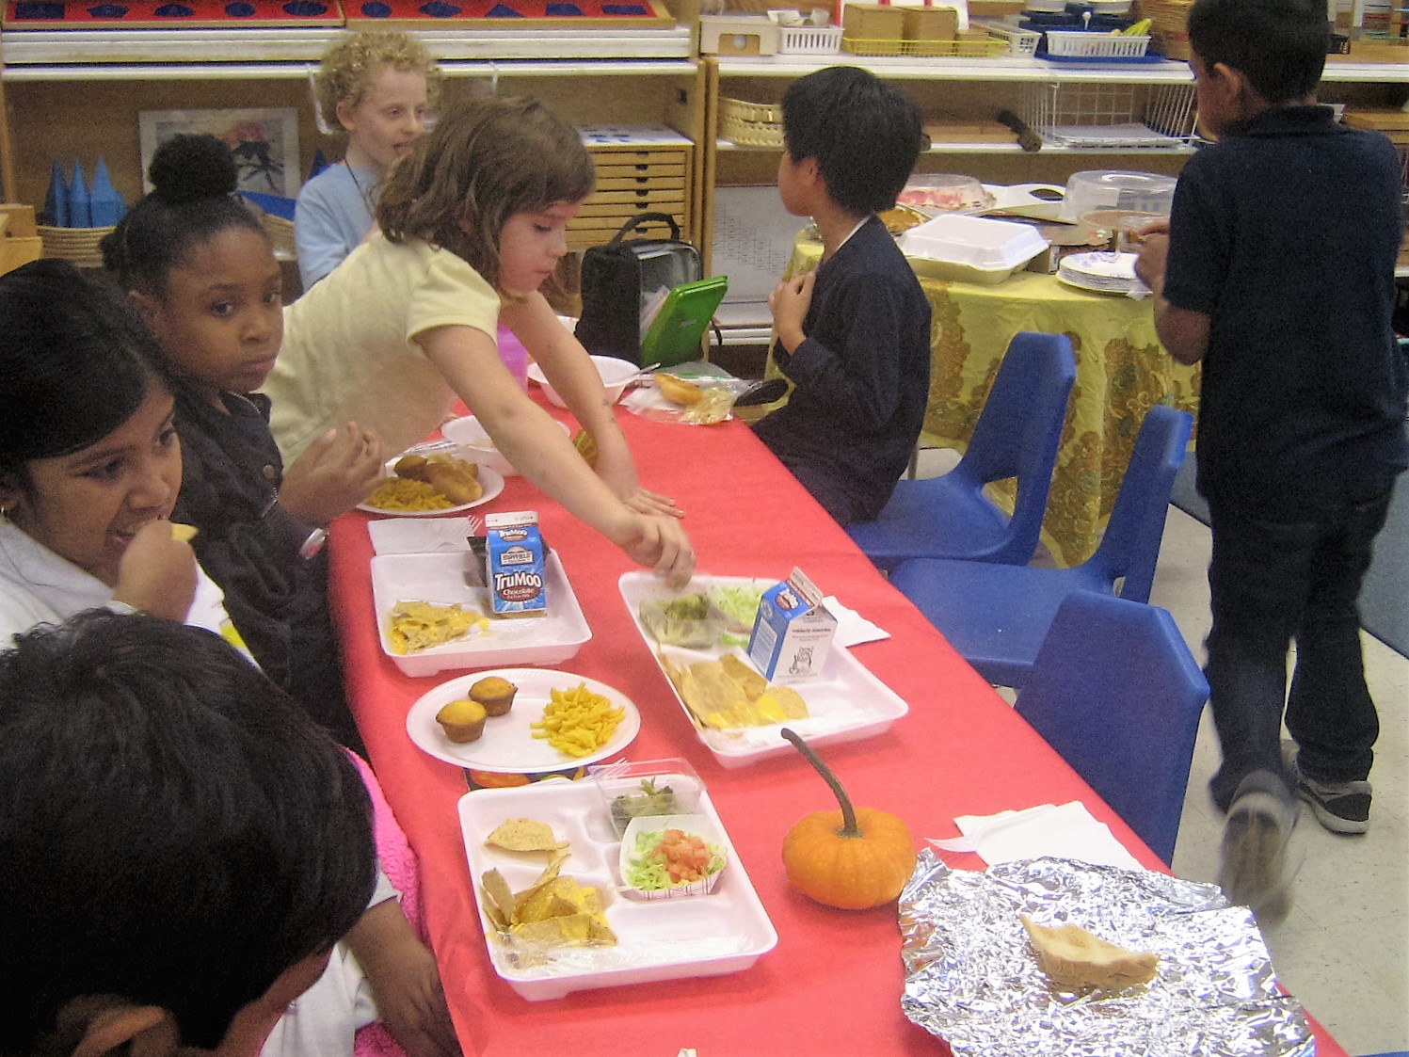
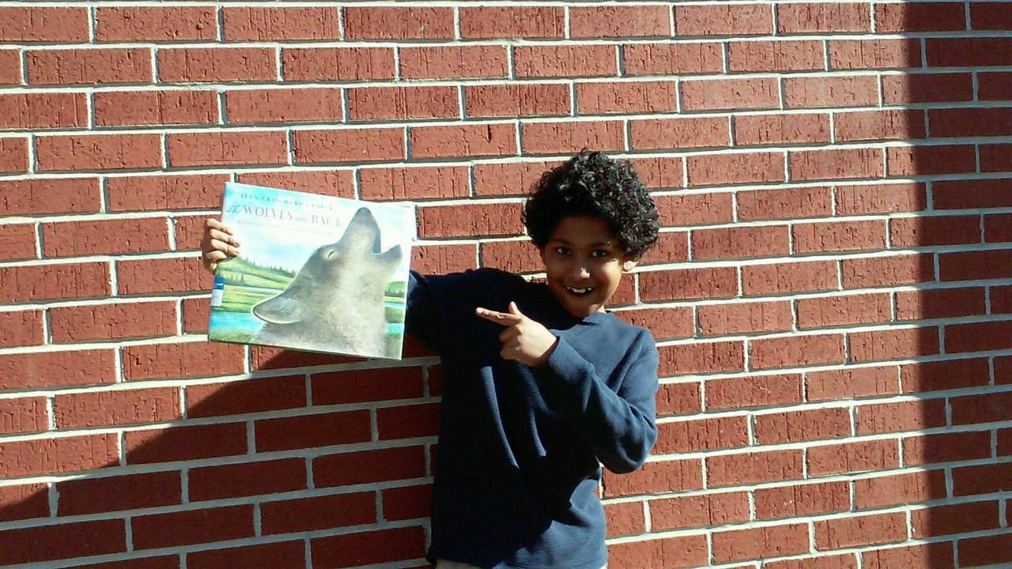
Photo of Roman by Dylan
Book Review by Roman
Edited by Becker
The Wolves Are Back
Book by Jean Craighead George
The wolf pack hunts while the wolf cubs stay in the den. They live in the Yellowstone National Park. One of the wolves stay with the cubs. The wolves grew up, they got taught by their mom and dad. They grew up and left their home far away. Hunters started looking for the pack. They passed by a bunch of elk. The wolves found some food but they had to keep going. They made another den hoping to be safe. They were finally safe from the hunters.
I think this book was very good! The paintings in the book are awesome. The book is good for 2nd-5th grade students. The book has 14 pages and lots of paintings. The A.R level is 3.6.

Roman

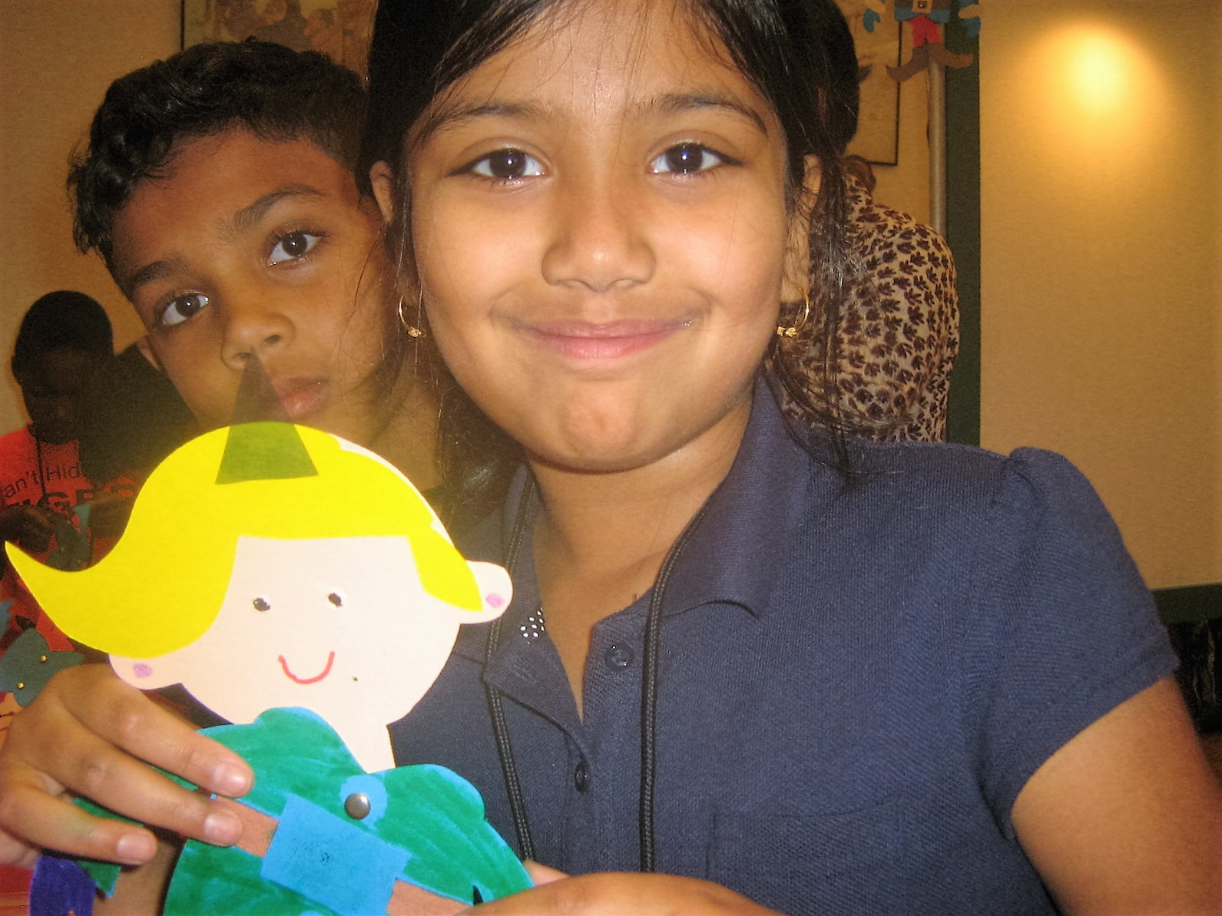
Photo of Jaima and Dylan by Hudson
Say PUPPET!
By Kara and Charlotte
Edited by Ronnie
The Puppetry Arts trip was very exciting! First we made a puppet and our own puppet show. Then we went to watched Rudolf the Red Nosed Reindeer. Rudolf is a reindeer that has a shiny red nose. There were three body puppets, the snowman, the lion and Bumble the Abominable Snow Monster. There was one main elf and his name we Hermey. One part of the play was when Clarice the girl reindeer told Rudolph, “I think you are cute” and Rudolph went crazy. We think that was very funny. You can become a member of the Puppetry Arts too. The Puppetry Arts Center has 12 shows a year you should go because it is great and you can save up to 50% as a member.

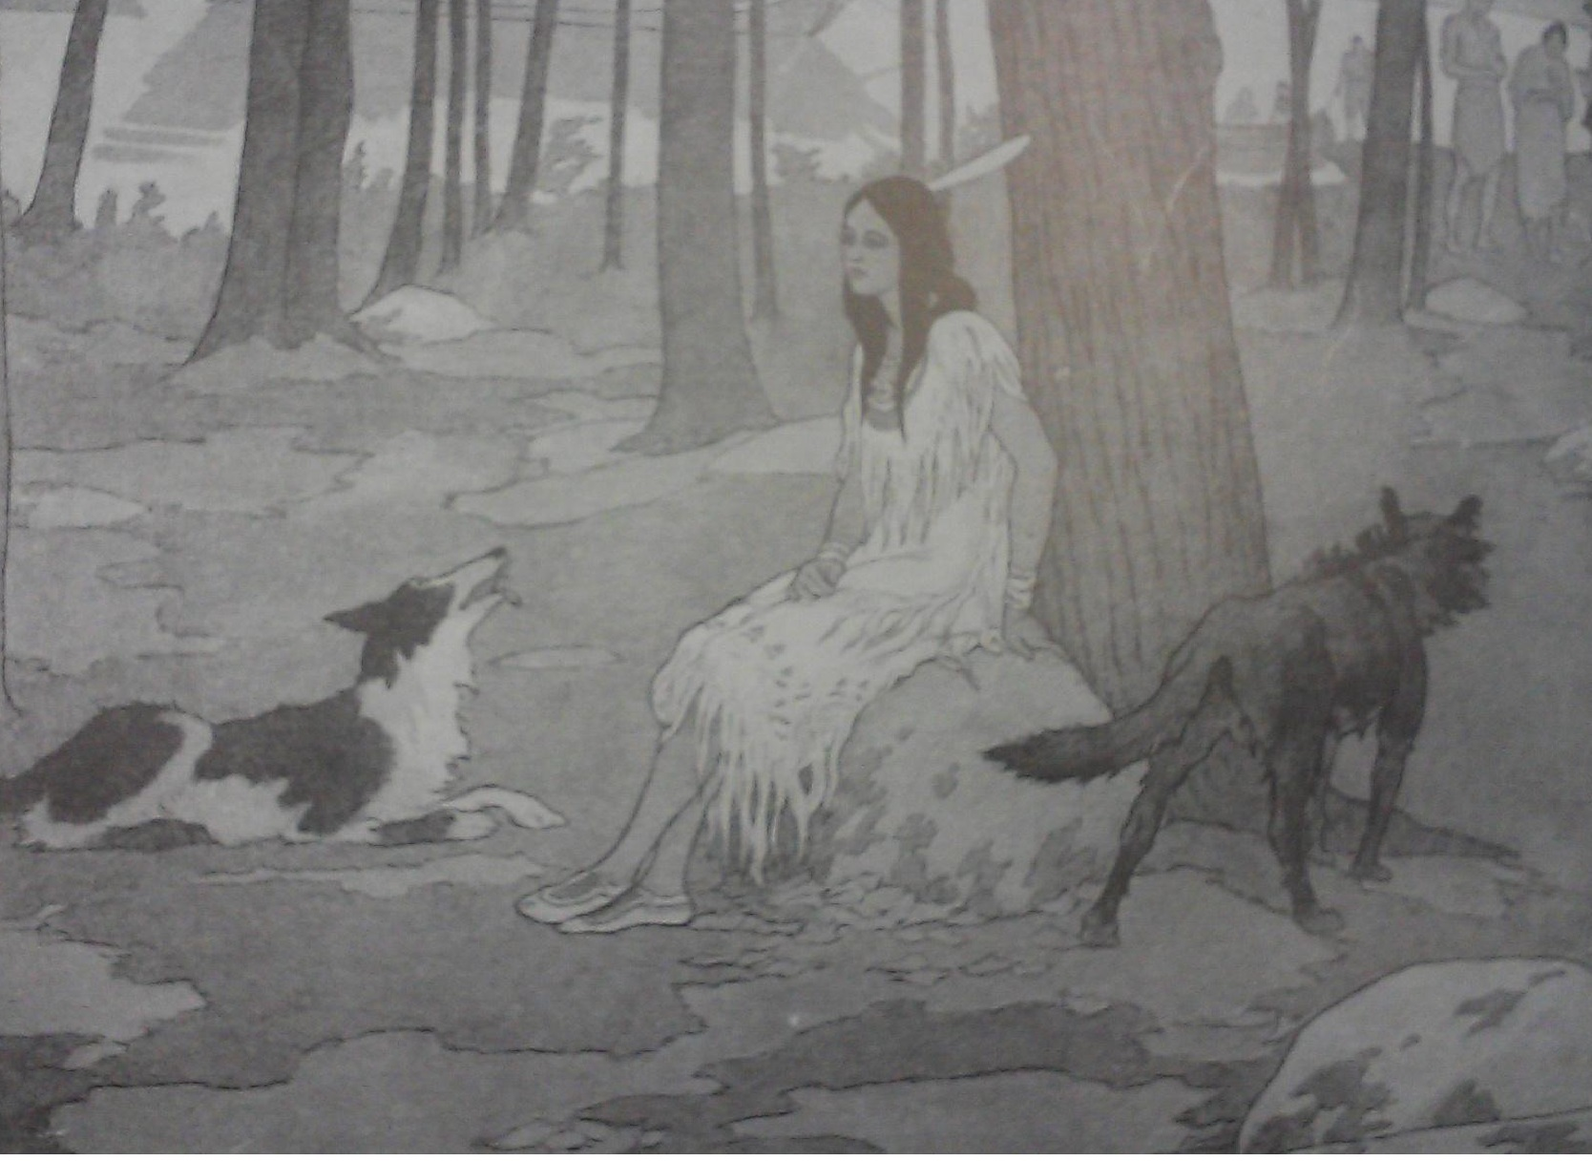
Photo from book Mary Musgrove by Amelia J. Pohl
Finding Mary Musgrove
By Ana
Edited by Aaron
Mary Musgrove was born in 1700. She was a Creek Indian princess. Mary Musgrove knew the Creek language and English so she was an interpreter for the Yamacraw tribe and for James Oglethorpe. James Oglethorpe started the colony of Georgia. In 1717 Mary Musgrove married John Musgrove also an English interpreter. Mary and her husband set up a post near Savannah. Later on in 1737 she married again with her husband’s assistant and they set up a trading post at Mount Venture on the Altamana River.

Photos to the left of Mrs. Mentonelli’s Silent Auction Project, the item was purchased by Kara’s Mom for over $30!

Fall Festival Raises Money

By Alexandra
Edited by Jaelyn
The Fall Festival was at Huntley Hills School on Saturday, October 24th from 10:00 to 3:00. There was a haunted house and cake walk and a lot of jumpies. There were a bunch of adults and kids. There was a little store outside. At the store there was Rice Crispy treats and drinks. The school has the Fall Festival once a year because it’s fun and a chance to raise money for teacher training and school programs and improvements. The Fall Festival money also goes to teachers for supplies in their classrooms.

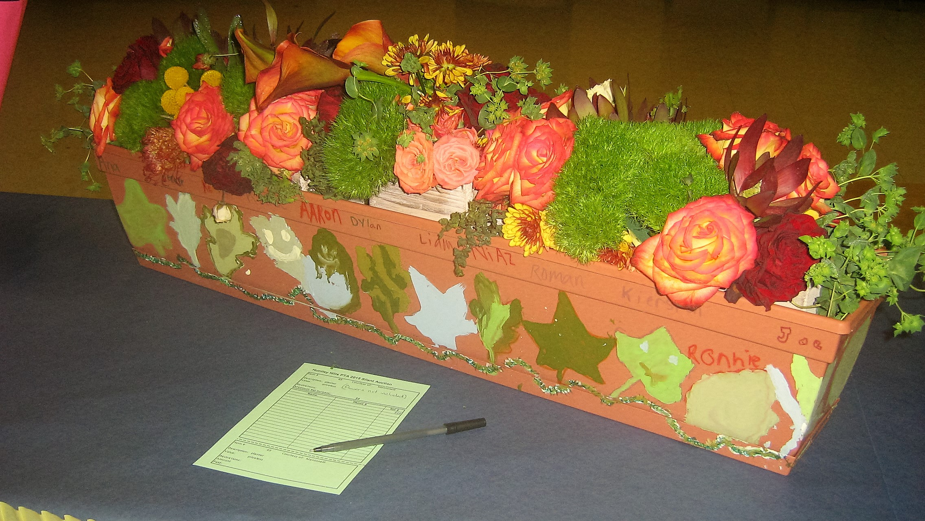
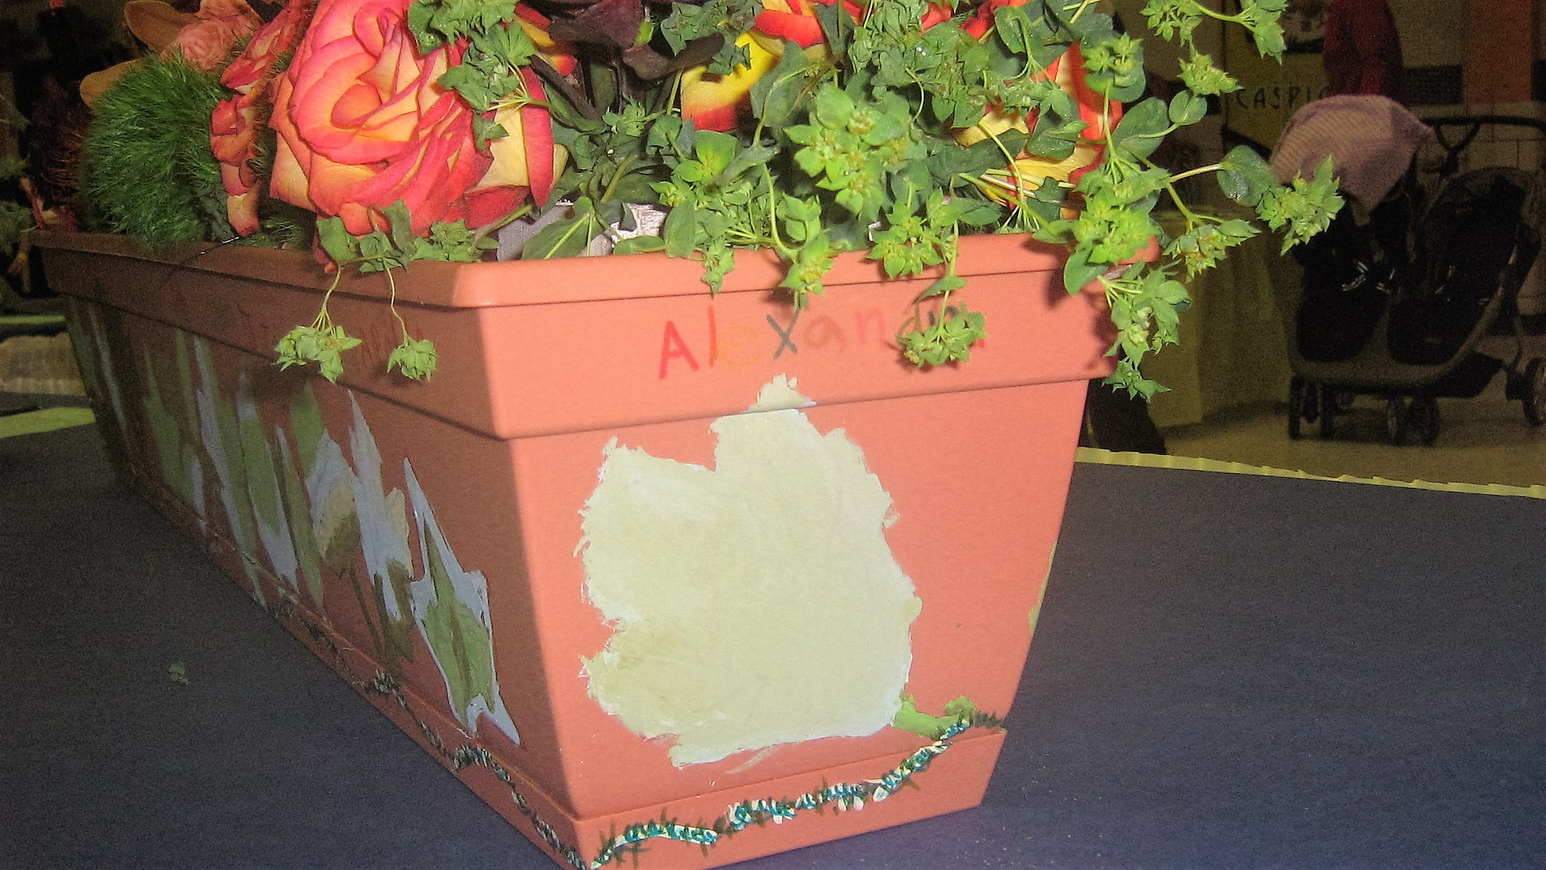

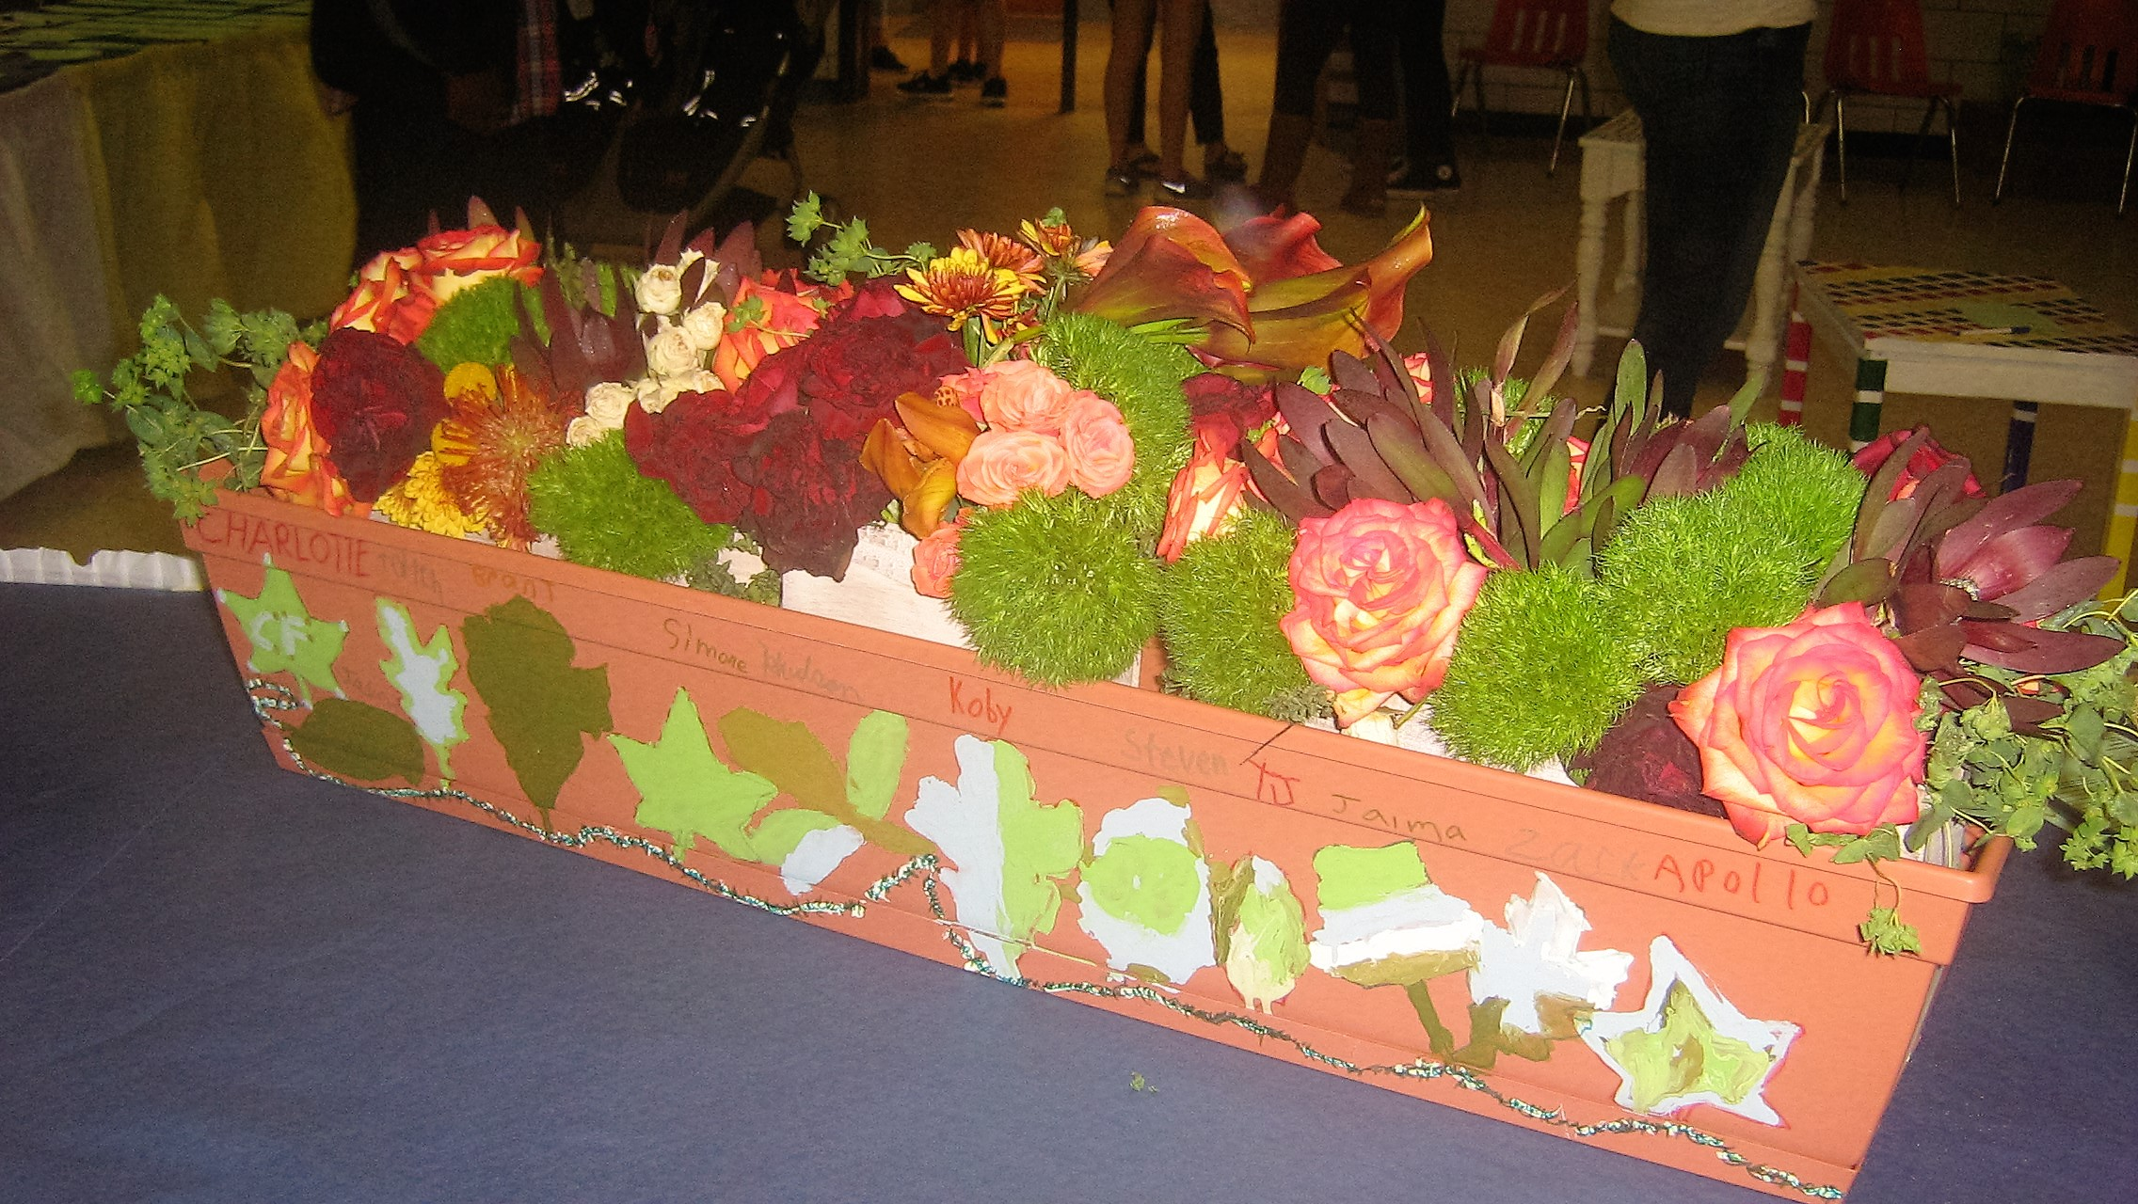

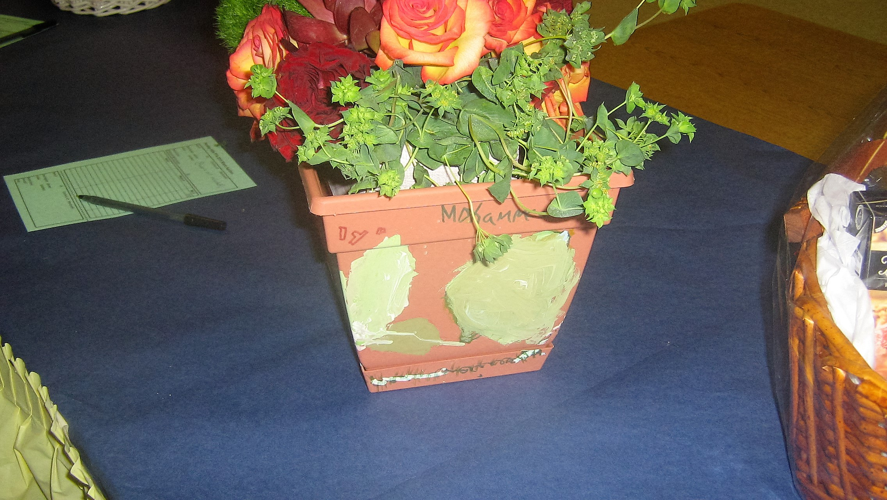

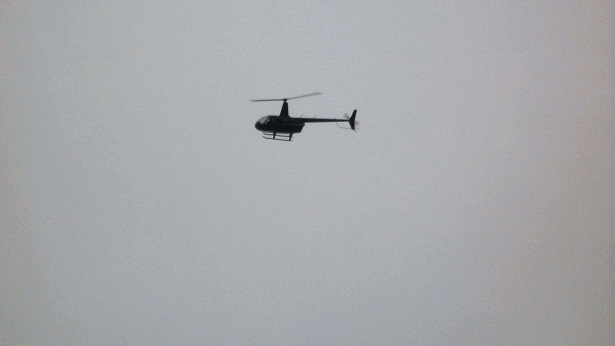
Photo by Koby
The Flying Classroom
By Niaz
Edited by Becker
All the third graders went on a field trip on Wednesday, November 4th, to The Flying Classroom, at Dunwoody High School. All the third graders went at 9:00 am and came back at 1:00 pm. Captain Barrington Irving is the pilot of The Flying Classroom. He will be landing a helicopter at the school. Captain Barrington grew up in Miami and built his own plane when he was little and it worked. There was three rotations for learning at the Flying Classroom. The first group ate lunch and talked with Caption Barrington. All the third graders ate lunch at the cafeteria. The second group did a stem building activity. The third group learned about stem careers. Careers are jobs that you do for money. The Flying Classroom has a website, www.flyingclassroom.com.
Special Thanks to:
Mrs. Powell
Ms. Haddock
Mrs. Kuutti
for their help with this publication.

Fall Festival Fun!
By Liam
Edited by Steven
The school had a fall festival. It was very fun. There were jumpy houses and a haunted house and a cake walk. It started at 10:00 and ended at 3:00. There was also face painting, hair dying, music, pony rides and a snow cone truck in the back. The jumpy house took less than 5 minutes to blow up the company that gave it to us is called Jump-n-slide, they will blow them up wherever you want them, you just call them up and they will come with the jumpies. There was a lot of children and parents. There was food and drinks. You needed tickets to go in the haunted house and on the cake walk. We have the fall festival every year because it’s fun and celebration of fall. Fall is when the leaves fall.
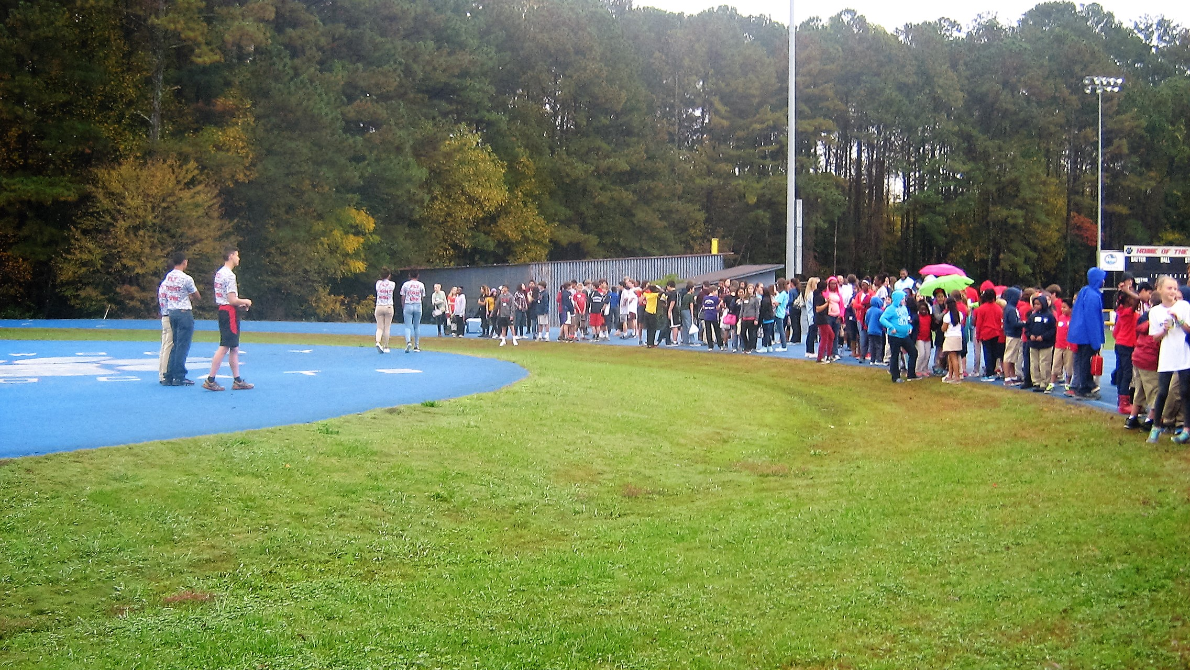
Photo of 3rd graders at Dunwoody High by Koby
Third Grade Field Trip
By Jaima
Edited by Ronnie
All thirds went on a field trip on November 4th at 9am. The place all thirds went was Dunwoody High School. When all 3rds got there all of us were outside clapping. When the helicopter landed somebody came out and then everybody came inside. All thirds ate lunch and then they went to see a video. When captain Barrington was a teen he made a plane.

